3

AI Agent & A2A Red Teaming

Executive Summary
The deployment of autonomous AI agents in enterprise environments has fundamentally altered the cybersecurity threat landscape. Unlike traditional GenAI applications that operate through stateless request-response cycles, AI agents maintain persistent state, execute multi-step workflows, and interact with external systems through standardized protocols (A2A, MCP). This paradigm shift renders existing red teaming methodologies inadequate, creating an urgent need for specialized testing frameworks that can assess behavioral vulnerabilities in autonomous, reasoning systems.

Technical Problem Definition

1. The Agent Security Paradigm Shift

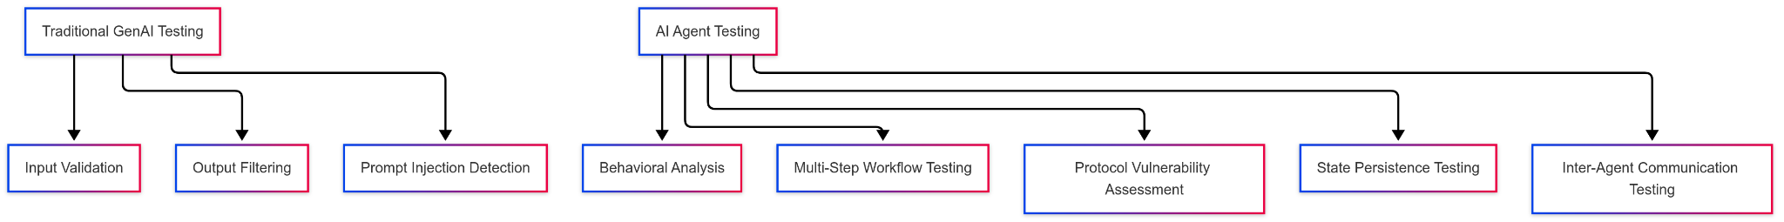
Traditional Approach Limitations:

- Stateless assumption: Each interaction treated independently
- Single-turn testing: No consideration of multi-step attack chains
- Input-focused: Emphasis on malicious prompts rather than behavioral manipulation
- Deterministic validation: Binary pass/fail security assessments

Agent-Specific Requirements:

- Stateful analysis: Testing across persistent sessions and memory states
- Workflow-aware testing: Understanding multi-step decision chains
- Behavioral validation: Assessing action patterns rather than text outputs
- Protocol-aware assessment: Testing A2A and MCP communication vectors

2. Multi-Dimensional Threat Surface Analysis
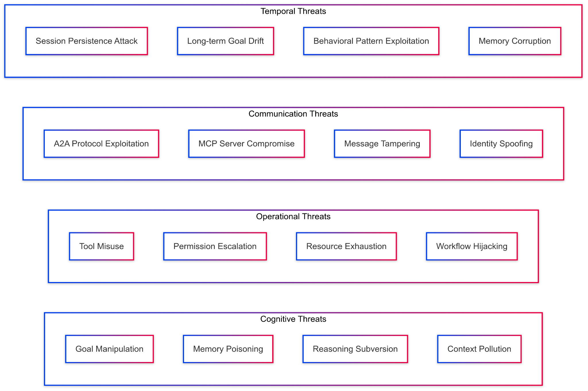

3. Agent Architecture Vulnerability Model
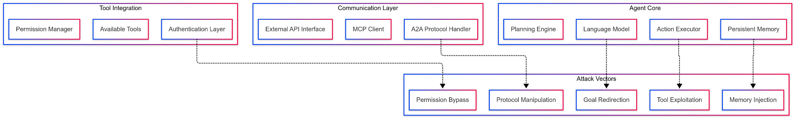

Technical Challenges

1. State Space Complexity
Mathematical Complexity: Given an agent with:

- M memory states
- G possible goals
- T available tools
- E environmental contexts
- C communication channels

The total state space = M × G × T × E × C

2. Protocol Integration Vulnerabilities
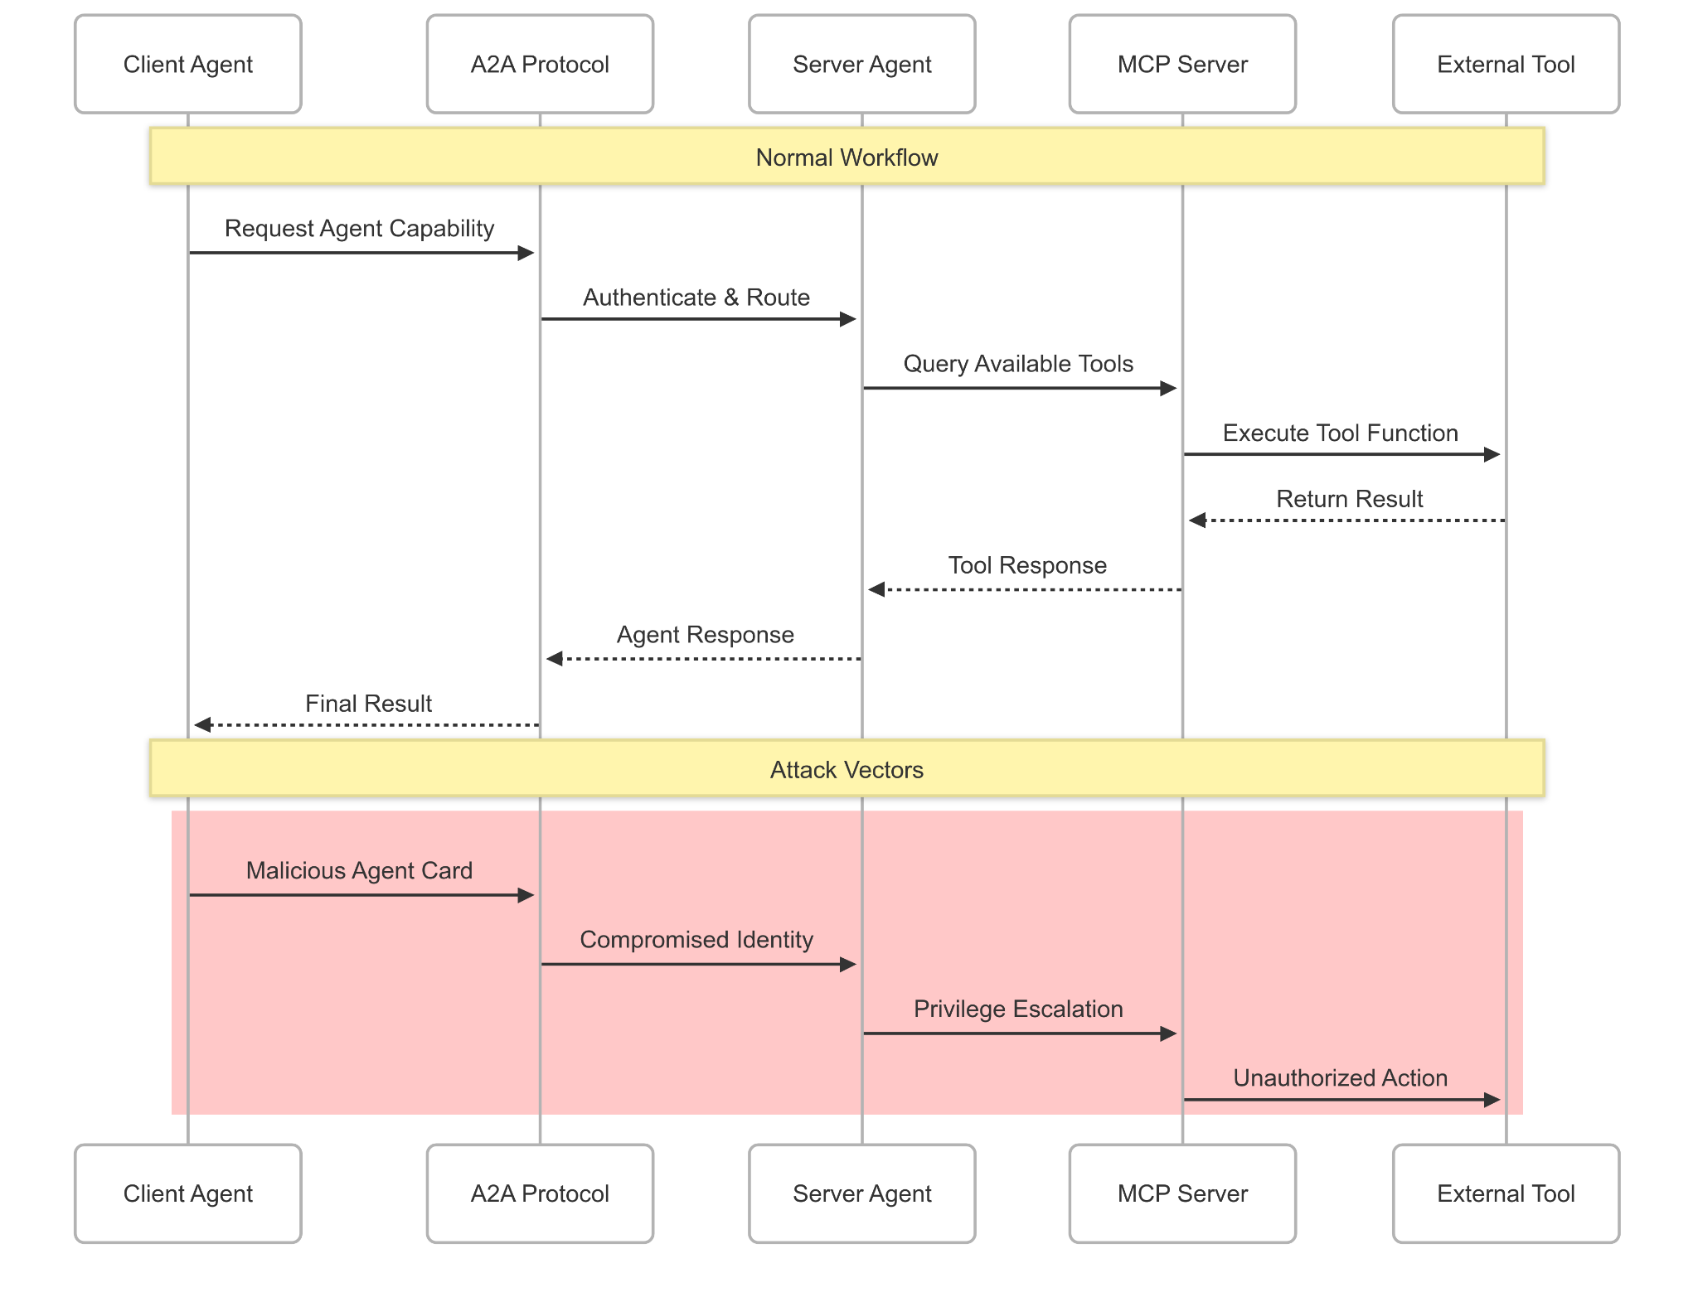

3. Behavioral Analysis Complexity
Traditional Testing: Input → Model → Output
Agent Testing: Context → Memory → Planning → Tool Selection → Action → Environment Impact → Memory Update
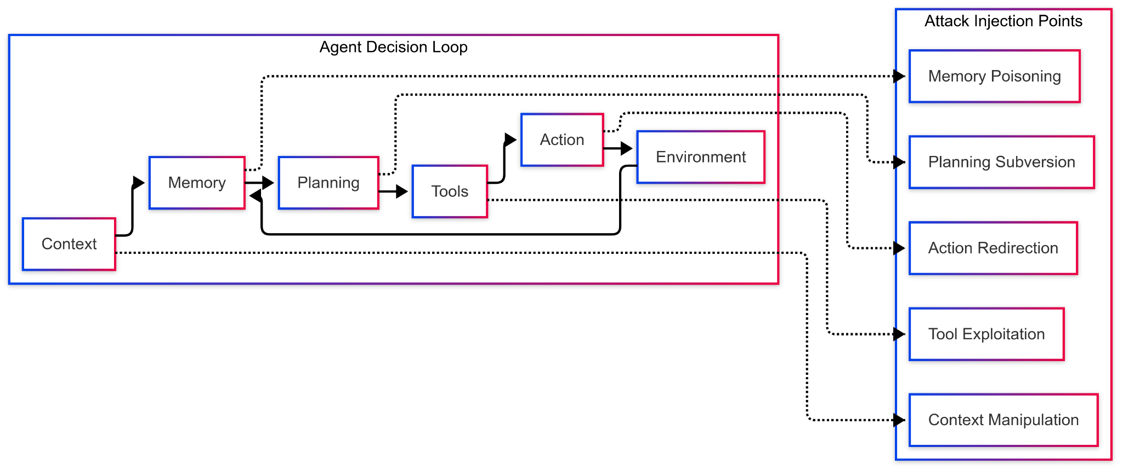

4. Emergent Behavior Unpredictability
Non-Linear Vulnerability Emergence:

- Single benign inputs can cascade into significant security breaches
- Agent learning can amplify initial vulnerabilities over time
- Multi-agent interactions create unpredictable systemic risks

Proposed Solution Architecture

1. Comprehensive Agent Red Teaming Platform (CARTP)
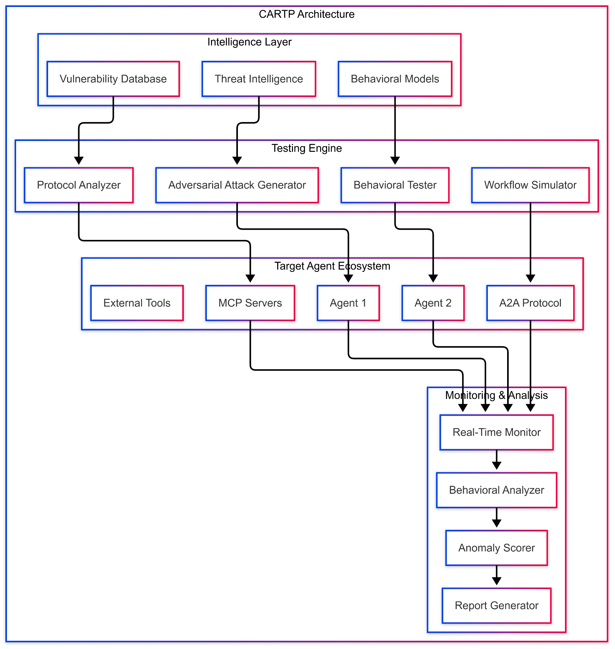

2. Core Technical Components

A. Adversarial Attack Generator (AAG)
Multi-Modal Attack Generation:

- Cognitive Attacks: Goal manipulation, memory injection, reasoning subversion
- Behavioral Attacks: Action sequence manipulation, workflow hijacking
- Protocol Attacks: A2A message tampering, MCP server exploitation
- Temporal Attacks: Long-term behavioral drift, session persistence exploitation

B. Behavioral Analysis Engine

C. Protocol-Aware Testing Framework

Expected Outcomes and Success Criteria

1. Quantitative Success Metrics
- Coverage: >95% of agent behavioral states tested
- Detection: <2% false positive rate for behavioral anomalies
- Performance: Real-time analysis with <100ms latency
- Scalability: Support for 1000+ concurrent agent testing

2. Qualitative Success Criteria
- Behavioral Understanding: Clear visualization of agent decision patterns
- Attack Chain Mapping: Complete traceability of multi-step vulnerabilities
- Protocol Compliance: Comprehensive A2A and MCP security validation
- Enterprise Integration: Seamless deployment in existing security workflows

Conclusion
The proposed Comprehensive Agent Red Teaming Platform (CARTP) addresses the fundamental inadequacies of traditional security testing when applied to autonomous AI agents. By focusing on behavioral analysis, protocol-aware testing, and multi-dimensional threat assessment, CARTP provides enterprises with the capabilities needed to secure next-generation agentic AI systems.

The technical architecture emphasizes real-time monitoring, automated attack generation, and comprehensive behavioral modeling to address the unique challenges of testing systems that think, plan, and act autonomously. Through systematic implementation of this framework, organizations can confidently deploy AI agents while maintaining robust security postures in an increasingly complex threat landscape.

